**Linear Motor Unit**

1. If the south pole of the magnets below is blue and the north pole is red, will the magnets attract or repel one another?

1. If the south pole of the magnets below is blue and the north pole is red, will the magnets attract or repel one another?

1. What is an advantage of using an electromagnet in a motor instead a permanent magnet? (Explain in one or two sentences.)

1. One end of the wire is connected to the positive terminal of the battery and the other end of the wire is connected to the negative terminal. What will happen if the wires are reversed?

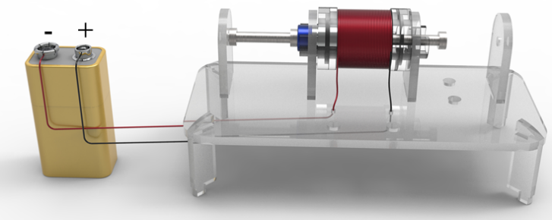

1. Which direction will the arm of the motor move when the north pole of the control magnet faces the north pole of the magnet in the motor? (Place a check mark beside *Left* or *Right*.)

□ Left □Right

1. Which direction will the arm of the motor move when the south pole of the control magnet faces the north pole of the magnet in the motor? (Place a check mark beside *Left* or *Right*.)

□ Left □Right

1. How quickly can a linear motor be moved back and forth by reversing the leads of its connection to a battery by hand?
2. Several times a second
3. Several times a minute
4. Reversing the leads will not have any effect on the motor.
5. How quickly can a linear motor be moved back and forth by using an oscillator controlled by a computer?
6. Several times a second
7. Several times a minute
8. Hundreds of times per second
9. Thousands of times per second
10. At what rate of movement is it possible to see the movement of the arm of the motor? Check all that apply.

* 10 times per second
* 50 times per second
* 70 times per second
* 100 times per second

1. At what rate of movement is it possible to hear the movement of the arm of the motor? Check all that apply.

* 10 times per second
* 50 times per second
* 70 times per second
* 100 times per second

1. At what rate of movement is it possible to feel the movement of the arm of the motor? Check all that apply.

* 10 times per second
* 50 times per second
* 70 times per second
* 100 times per second